1. Connect
Human are social creatures. We crave connection just as we crave food and water. NEF's report showed relationships with other people are fundamental to our happiness. Close relationships with family and friends give us support and a sense of meaning in our lives. Wider social networks give us a sense of belonging. So you should put effort into keeping the connections you have alive, and make new ones.
So commit to talking to people everyday. Eating with loved ones gives us a boost - aim to do it at least once a day. Also, make the effort to share the good things about your day when you're asked, not just the negative bits. Telling someone that you're grateful to have them in your life - and why - is a wonderful exercise.
Focusing on the person in front of you is important too. That means put your devices in your bag or pocket when you're with other people. It helps to deepen our sense of connection.
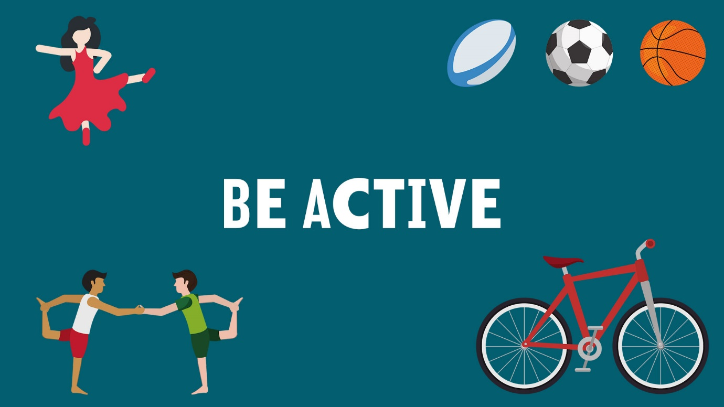

2. Be active
Exercising releases endorphins that make us feel good. The simpliest way to think about it is healthy body = healthy mind. Being active doesn’t have to mean the gym, triathlons or lifting weights (though those are great and will give you a big sense of achievement).
Just find the activity that fits into your daily life. You get bonus points if it includes a friend or being out in nature. Go for a walk, try yoga, join a team sport or just dance in your kitchen when you're cooking. Leave your car at home one day and walk or cycle.
Exercise beats stress and makes us feel good about ourselves. Regular exercise is also linked to better sleep.

3. Take notice
It's a cliche to say how busy we all are these days, stuck in our phones or our heads and unable to tolerate doing nothing for a few minutes. But the truth is, internal chatter does chip away at our wellbeing. It distracts us so much that we don't appreciate or notice what's around us. We are mind-full instead of mindful.
This is easily fixed. Just take a few moments to be aware of what is going on within you and around you. Practices like this - one of the exercises of minfulness - can free us, just for a few moments, from living in the past or future. It will genuinely make our day-to-day lives more enjoyable.
Here's what you can do: Be curious. Look up and look around on your daily commute and you might see something beautiful you didn't notice before. Notice the changing seasons. Savour the moment, whether it's a morning coffee or clean sheets or a warm hug. Be aware of the world around you and what you are feeling. Sign up for a meditation class and notice the difference in your mood after six weeks of daily mindfulness.

4. Keep learning
Learning opens us to new ideas and keeps us curious and engaged. It usually comes with a sense of accomplishment which can boost our confidence.
Learning doesn't have to mean classes or courses. Learning by doing is a very satisfying way to broaden your skillset. .
So try something new. Rediscover an old interest, especially one you had as a child. Sign up for that evening course you've been curious about. Learn a practical skill like changing a tire or fixing a bike chain. Challenge yourself to learn a new instrument or try a new recipe.

5. Give
Doing good is good for us. Helping others makes us feel needed and valued, and of course those we help get a benefit. In all, giving leads to a more compassionate society.
Giving ranges from random acts of kindess to significant commitments. Do something nice for a friend, or a stranger. Give an surprise gift. Give up your seat. Give a compliment. Thank someone. Smile - especially in traffic.
Volunteer your time and skills. Fundraise for a cause you are passionate about. Join a community group (Tidy Towns need you!). All these activities can be incredibly rewarding and satisying. It will create and strengthen connections with the people around you, which will lead you back to no 1; Connect!

