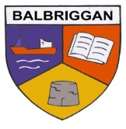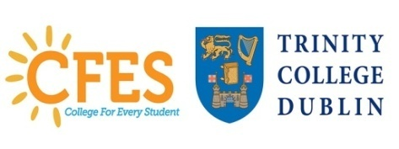
Balbriggan Community College
Dublin & Dun Laoghaire Education & Training Board

Pine Ridge, Chapel Street, Balbriggan, Co. Dublin Principal: Mr Emmet Sheridan
Tel: 8412388 (Office) Deputy Principal: Mr. Fergal Mc Mahon
Fax: 8413818
Email:-balbriggancomcol@eircom.net
School Roll Number:-70010V

01/11/18

Visit your local school

We would like to extend an invitation to visit our school during college awareness week. This is an invaluable opportunity to share your college/work/life experiences with our students. We especially value the time you can give to share your wisdom and personal experience, thus expanding our students’ future visions and life choices.
Do check out the following websites
www.college aware.ie and our school website
http://www.balbriggancommunitycollege.com

If you are available, do inform us in any of the following ways:
Complete the enclosed form, give to your teacher/student contact and we will contact you.
Contact the school via email or directly by phone.

During college awareness week, we are dedicating a morning, for a mini careers fair.
This will run from 9.30-12.15 on Friday, 23rd November. During this time, students in groups of 5-6 will meet you, the guest speaker for approx. 15 minutes. I enclose a template for the volunteers, entitled My Education Story/My career path. This is an excellent guide for the meeting with the students.

We would particularly like to target this time and date, but if you are available at a different time, do let us know.If you have any questions do contact and we will be delighted if you can be involved.

Yours sincerely,

Mr. E. Sheridan Mr. F. Mc Mahon Mrs. A Mannion
,
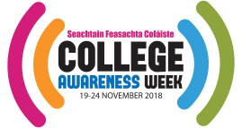

CFES TEAM BCC

BCC International School of Distinction
My education Story/My Career path

NOTE: The content of the talk/story depends on what speakers/writers are comfortable with. Below are a few points they might cover with a few sample answers. This template could form the basis of a short talk/series of speakers or a one-or-two page ‘story’ to be displayed on the noticeboard/table.

1. Who I am and what I do

2. What I studied in which college and why/ how I trained for my craft and why I chose it.

3. What was my experience of university? Or of training?

4. Any obstacles along the way? – failures, repeats, changing course, feeling unsure of your choice? If so, how did you overcome these and did they contribute to your success in the end? (Knowing that happy/successful people have failed in the past is often more inspiring to young people than hearing about all the success!)

5. Highlights of college/training - what did I enjoy most?

6. What has going to college/choosing this trade meant to my life? ( Job, friends, hobbies)

7. What’s the best advice I got - or could give - to encourage young (and mature) people to consider further education/training? Did anyone inspire me to go to college/do well –can I encourage my audience to look for similar role models? Can I encourage them to dream big and to feel that a post-secondary education/training is within reach?

8. Perhaps finish by mentioning College Awareness Week. You’re never too young – or too old – to make big plans. And maybe you could wish your audience well with thinking about an apprenticeship, a further education course, a university degree – a great future!

Volunteer name: ________________________________

Career area: _____________________________________

Contact details;
Email; __________________________________________Please print

Phone details; ___________________________________________

Available times

Mini Careers Fair Availability yes ______ No ____

Other availability

Day Date Time

Key school contact ________________________

